HMH
Enterprise Webservices Project
Application KT Handbook
Version No.1.0



 | Prepared By / Last Updated By | Reviewed by | Approved By
Name | Manish Mehndiratta and Manoj Das
Role
Signature
Date | 9th September 2009

Table of Contents

1.0 Introduction 3
1.1 Purpose 3
1.2 Intended Audience 3
1.3 Definitions and Acronyms 3
1.4 References 3
2.0 Application Overview 4
3.0 High level Architecture 5
3.1 Architecture 5
4.0 Technical Overview 6
4.1 Logical Design: 6
4.2 Deployment Architecture 6
5.0 Tools & Technologies 7
5.1 Tools & Products 7
5.2 Environments 7
6.0 Interface Specifications 8
6.1 CCPreAuthorization 9
6.2 submitCCMarkforSettlement 16
6.3 FindEtailCustomer 22
6.4 GetCustomerDetail 26
6.5 GetCustomerRelationships 30
6.6 GetCustomerSubstitutions 34
6.7 CreateEtailCustomer 38
6.8 CreateSundryCustomer 42
6.9 GetMaterialDetail 46
6.10 GetMaterialSubstitutions 50
6.11 SubmitSale 54
6.12 SubmitSample 58
6.13 FindTransactions 62
6.14 GetInvoices 66
6.15 GetShipments 70
6.16 GetTransactionDetail 74
7.0 Change Log 78

Introduction

Purpose
The purpose of this document is to provide the technical design for the services in the Enterprise_Webservices TIBCO project. This project contains all the web services that are a part of the Sunrise project. These services provide a web interface to access and/or update SAP. This is required for the existing SFA applications and eCommerce solution which need to update SAP. The project contains OTS Sunrise Business Services (SBS), provided by SAP systems.

Intended Audience
  - Cognizant Onsite Delivery manager
  - Cognizant Project Manager
  - Cognizant Project Leader
  - HMH Project Leader
  - Team members
  - QA Representative

Definitions and Acronyms
Acronym | Term
SBS | Sunrise Business Services
SCM | Supply chain management
OTS | Order To Shipment

References
eRoom location of enterprise webservice Project
https://eroom.dp.hmco.com/eRoom/Sunrise/SunriseTechnical/0_22117

XML Canon (Enterprise Webservice Code)
http://neduapp001:8088

Application Overview

Enterprise Webservices project is developed to create the web services for the Sunrise project.

Legacy systems through TIBCO need to interact with SAP to support various business processes like Invoicing, Order Status etc. within the OTS space. The TIBCO project has defined web-services to support these requirements. These web-services make a remote function call to the SAP exposed services. Most of these web services are RPC based both synchronous and asynchronous.

TIBCO web services would define the WSDL (Web Service Definition Language) for each of these services. The legacy systems, i.e. eCommerce and SFA systems would use these to develop the client for these web-services. The legacy systems would then use these web clients to interface with the TIBCO exposed web-services.

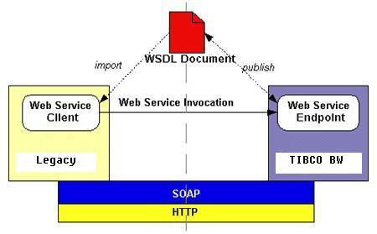

High level Architecture

Architecture
The diagram below gives the architectural overview of EnterpriseWebservices Project. Here, Legacy systems are making SOAP calls via TIBCO to interact with SAP.

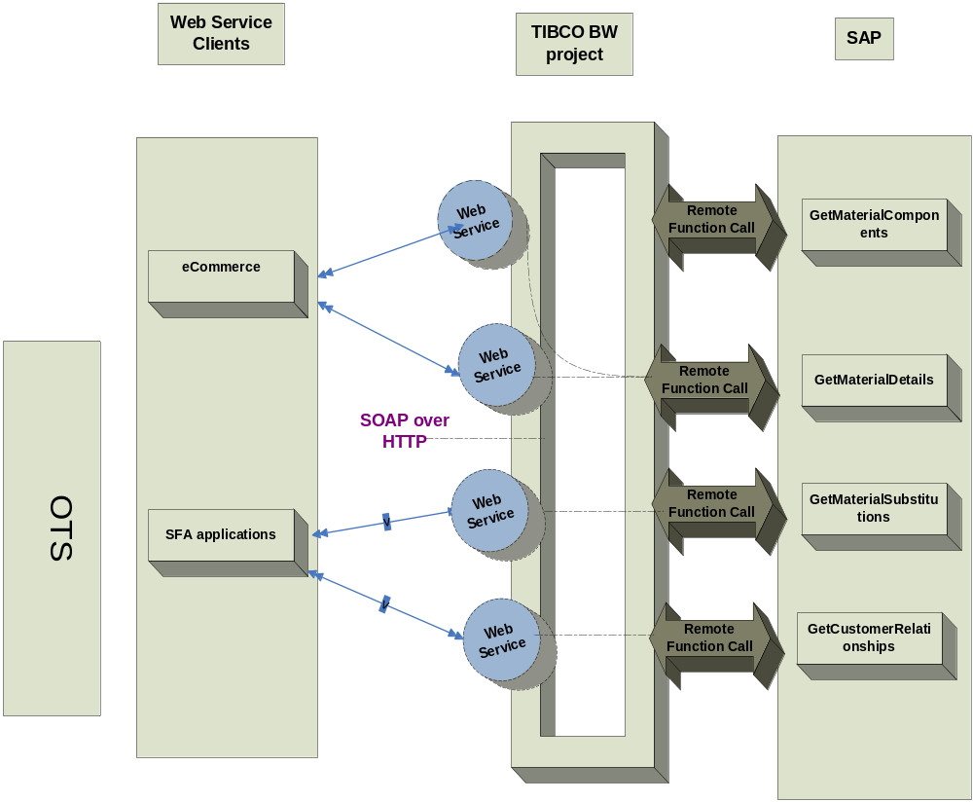
Fig: Enterprise_Webservice Architecture

Technical Overview

Logical Design:

Legacy Systems(SOAP CLIENT)

TIBCO
Web Service
SAP
Reply

Sends the request
SAP Remote function call

Reply

Deployment Architecture

Applications are deployed in all environments, i.e.: Development, QA, Staging and Production. All the Inbound and Outbound interfaces are built and deployed as separate EAR’s.

TIBCO deployment servers are:

Development | neduapp001
Staging | neduapp001a, neduapp001a
QA | wdcqaua01
Production | nepuinf005a, nepuinf005b

Applications are deployed in all environments, i.e.: Development, QA, Staging and Production. All the Inbound and Outbound interfaces are built and deployed as separate EAR’s.

Tools & Technologies

Tools & Products
Following Tools are used for this application.
- SAP
- TIBCO BW 5.4
- TIBCO Designer 5.5
- SAP R/3 Adapter
- TIBCOEMS

Environments

Different configurations and servers have been used in all the environments for communication between SAP, TIBCO. Those are:

Development environment
SAP servers: SAP DEV 110
TIBCO: neduapp001
QA environment:
SAP servers: SAP Q02
TIBCO: wdcqaua01
Staging environment:
SAP servers: SAP Q01 (aka Q100)
TIBCO: neduapp001a, neduapp001b
Production environment:
SAP servers: SAP P01
TIBCO: nepuinf005a, nepuinf005b

Interface Specifications
Enterprise Webservices project consists of the interfaces mentioned below. All the interfaces have been described below with their configuration details, sequence diagrams, Process flow diagrams and the flow charts of their execution.

- CCPreAuthorization
- CCMarkforSettlement
- CreateEtailCustomer
- CreateSundryCustomer
- FindEtailCustomer
- GetCustomerDetails
- GetCustomerRelationships
- GetCustomerSubstitutions
- SalesRepLocator
- GetMaterialATP
- GetMaterialDetail
- GetMaterialSubstitutions
- SubmitSale
- SubmitSample
- FindTransactions
- GetInvoices
- GetShipmentsDetails
- GetTransactionDetails

CCPreAuthorization

In this interface, SAP TIBCO would wrap the authorization functionality provided by an external vendor – PaymentTech. SAP would invoke a RFC in TIBCO passing in the desired credit card data. TIBCO would translate this data as per the SOAP service requirements. This process, which acts as a SOAP client would then send the request over JMS to the SOAP server. The server which has already has an open link to Paymentech, converts the SOAP request into Paymentech format, and sends it over the dedicated TCP link to Paymentech. Upon getting the response back from Payementech, the web service will convert the data into a SOAP response, and send it back over to the SOAP client. The SOAP client then converts it back to SAP format, and sends to back to the waiting RFC call.

This process contains the logic to submit the request to Paymentech. This would require getting the information from the SOAP client, and converting this information into the required Paymentech format as per the mapping rules in the mapping spreadsheet

Configuration Details:

JMS Specifications
Transport type | JMS Queue / JMS Topic
Delivery mode | Persistent / Durable
Destination Queue / Topic Name | COM.HMCO.SUNRISE.DEV.PAYMENTECH.CONNECTION.OPEN
SSL | No

Paymentech Link:

TIBCO will open and maintain a 24/7 link to Paymentech. This connection will be opened and maintained as per Payment specifications – “Connecting to Paymentech with TCP/IP For Online Transactions”.

The following functions will have to be implemented in TIBCO for connecting to Paymentech:
- ReadTCPData: This function would read all the data coming from Paymentech onto the link. Depending upon whether the data read is a handshake signal for open link/close link or a heartbeat request or a Authorization response, it will notify the appropriate function. For authorization responses, it will use the transactionID as the key to relate to the waiting request thread.
- WriteTCPData: This function would write data stream on to the Paymentech link, for Paymentech to pick up the data and process it. It will simple write whatever data is passed to it, on to the link
- OpenLink: This function would try to open the link, as per the handshaking steps required by Paymentech. This function will wait for notifications sent by the ReadTCPData triggered by the open link handshake signals sent by Paymentech. If an error occurs, it will try for a finite (20) number of times to connect, after which it would raise a notification to the support contact.
- CloseLink: This function would try to close the link, whenever an error occurs, and link needs to be closed. This function will wait for notifications sent by the ReadTCPData triggered by the close link handshake signals sent by Paymentech.
- SendHeartbeatResponse: ReadTCPData would notify this function, when a heartbeat request comes in from PaymentTech. This function acknowledges by sending a heartbeat response back onto the link

Processing steps for authorization request

SAP would send authorization request to TIBCO, and wait till the response comes back from TIBCO. This would be end to end synchronous. However Paymentech interface is asynchronous. TIBCO would forward the request to Paymentech, storing the unique transaction ID for that request. Upon receiving a response, TIBCO will relate it to the appropriate request, using the unique transaction ID. This response will be returned back to the waiting SAP call.
For sequencing all Payment read and write processes, wait and notify activities will be used in the process.

Retry Logic:

As per the requirements, if Paymentech does not respond in 20 seconds, TIBCO will send the request again. If still no response comes back in next 20 seconds, TIBCO will have to send an error back to SAP informing about the error. For errors, TIBCO will be populating the “RTEXT” field in the response structure. This field will have two parts, response code and description. The description would be the exact error message. Code would be “B” for all Paymentech / system related errors (which are time based and could pass through at some later point of time), and “C” for all data related errors.
For the current release, retry attempt is fixed to 1.

Batch of authorization requests:

In certain business scenarios, it is possible to have multiple authorization transactions to come in one request. In this case, the following logic is required:

- Relate individual transaction request to its response
- Group all the transactions of one message together
- Send this batch of response, in one single message.

The transactionID generated will be used to implement this logic.

Performance Indicators:

There is a SLA for the interface to respond in 60 seconds, end to end. If no response is
generated in this time frame, the interface would time out and returns a timeout error to
the eCommerce/SFA client. When a timeout error occurs, there is no guarantee about
the transaction status. It may or may not be processed by SAP. The client could try re-
submitting the request at some later point of time.

Sequencing diagram:

The message flow in the following message flow diagram represents the sequence of events for processing of credit card data coming from the SAP_OTS system.

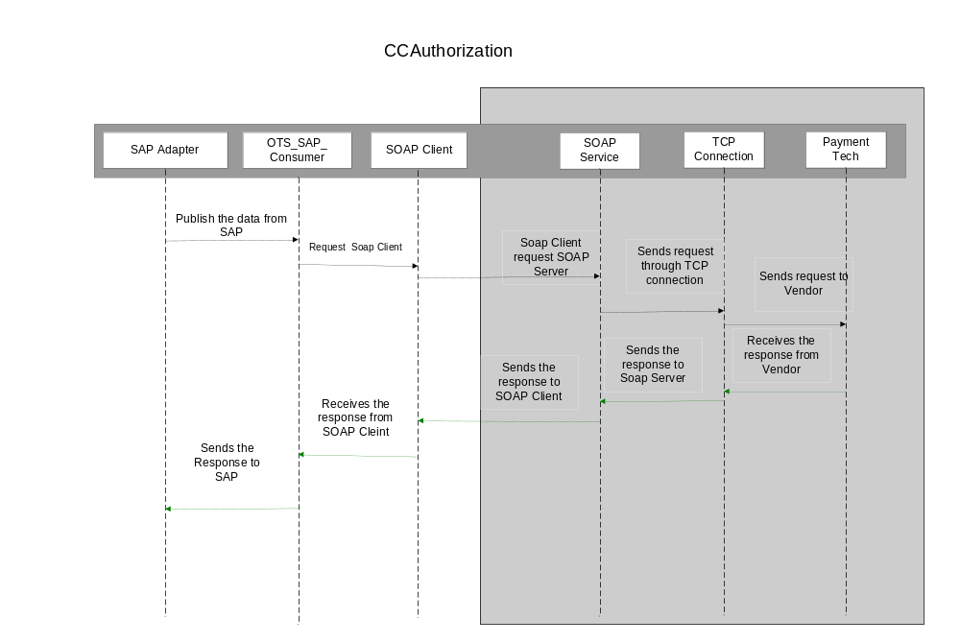

Process flow diagram:

The process steps for CCAuthorization process is listed below.

1 | Create the EAI header for the incoming SOAP request
2 | Log the SOAP request
3 | Transform the SOAP request to Paymentech request format
4 | Send the request on the open Paymentech link
5 | If an error occurs go to step 9
6 | Wait till a response is got for this request
7D | Map the Paymentech response to SOAP response
8E | Log the SOAP response
9F | Send the SOAP response to the client and exit
10 | Call the exception handling response
11 | Map the Paymentech exception to SOAP fault
12 | Log the SOAP fault
13 | Send the SOAP fault to the client, and exit

A | Keep reading for data on the Paymentech link
B | If an authorization response is obtained, then check for the transaction ID and notify the appropriate waiting request thread – step 7D
C | If an exception occurs while reading the data on the link, call step 9

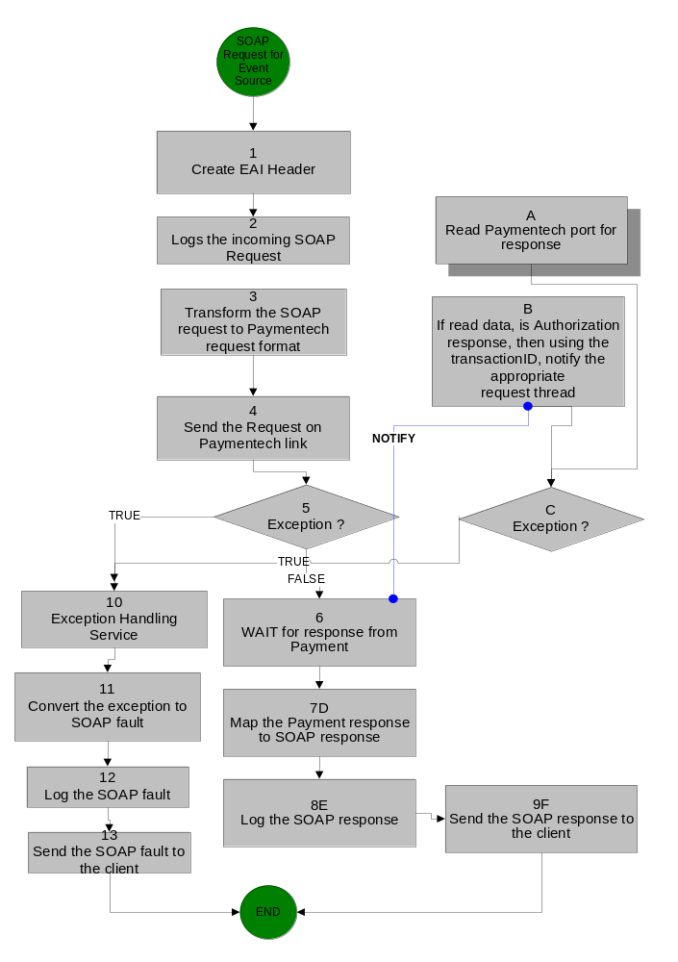
Logging and Error Handling:

All TIBCO projects log messages and errors to a central core technical services project. Every event that crosses the TIBCO boundaries is logged. Exceptions are also logged. Below is a list of exceptions that will be handled by this process
.

Activity | Exception Scenario | Exception Type | Comments
TCPOpen | Paymentech | System | TIBCO will try to connect for 20 times, if it still fails, a notification alert will be sent to support contact
TCPRead | Paymentech does not respond | System | TIBCO will send an error message back to SAP, informing that a timeout occurred (TIBCO will implement one retry attempt)
Mapper | Data transformation | System | There should be a proactive error acknowledge sent to the TIBCO support staff that includes some sort of descriptive text of the problem & the specific field or rule that has failed

This interface involves sensitive information like credit card numbers. The security guidelines for HMCO require that data should not be logged by TIBCO. SAP would log all the authorization requests in a secured manner. TIBCO will log process entrance, exits and exceptions as it normally does; only it will not log any data, i.e. payload will not be logged.
From a tracking perspective, the transaction ID logged in TIBCO could be used to relate to the payload in SAP.

Errors:

As per the requirements, if Paymentech does not respond in 20 seconds, TIBCO will send the request again. If still no response comes back in next 20 seconds, TIBCO will have to send an error back to SAP informing about the error. For errors, TIBCO will be populating the “RTEXT” field in the response structure. This field will have two parts, response code and description. The description would be the exact error message. Code would be “B” for all Paymentech / system related errors (which are time based and could pass through at some later point of time), and “C” for all data related errors.

System down scenarios for Credit Card Authorization
 | SAP - TIBCO is down | TIBCO-Paymentech is down
Error Message | Authorization not successful  TIBCO_D01_110_ZCCARD_AUTH_EX not registered  No response from clearing house | Time out-CCAuth service not reachable
Possible cause of error | TIBCO component that listens to SAP requests is down | TIBCO component that connects to Paymentech is down or Paymentech itself is not reachable
Action taken by the system | If the monitoring tool detects that any component is down, it will try to start is again. The details of the error are logged in TIBCO database and log files | If Paymentech is not reachable, TIBCO will keep retrying to connect. The details of the error are logged in TIBCO database and log files
User Resolution | User is expected to contact the App-Support team immediately | User is expected to submit the transaction, at a later point of time. If the user repeatedly sees this message, he is expected to contact the App-Support Team

eRoom Location:

https://eroom.dp.hmco.com/eRoomReq/Files/Sunrise/SunriseTechnical/0_37502/

submitCCMarkforSettlement

In this interface, SAP TIBCO would wrap the PostAuthorization functionality provided by an external vendor – PaymentTech. SAP would invoke a RFC in TIBCO passing in the desired credit card post authorization data. TIBCO would translate this data as per the SOAP service requirements. This process, which acts as a SOAP client would then send the request over JMS to the SOAP server. The server will open a link to Paymentech, converts the SOAP request into Paymentech format, and sends it over the dedicated TCP link to Paymentech.

This process contains the logic to submit the request to Paymentech. This would require getting the information from the SOAP client, and converting this information into the required Paymentech format as per the mapping rules in the mapping spreadsheet.

Configuration Details

JMS Specifications

Transport type | JMS Queue / JMS Topic
Delivery mode | Persistent / Durable
Destination Queue / Topic Name | COM.HMCO.SUNRISE.DEV.PAYMENTECH.CONNECTION.OPEN
SSL | No

Paymentech Link:

TIBCO will open and maintain whenever it needs to send data to Paymentech. This connection will be opened and maintained as per Payment specifications – “Connecting to Paymentech with TCP/IP For Batch Transactions”.

The following functions will have to be implemented in TIBCO for connecting to Paymentech:

- ReadTCPData: This function would read all the data coming from Paymentech onto the link. Depending upon whether the data read is a handshake signal for open link/close link or a heartbeat request or a PostAuthorization response, it will notify the appropriate function. For PostAuthorization responses, it will use the transactionID as the key to relate to the waiting request thread.
- WriteTCPData: This function would write data stream on to the Paymentech link, for Paymentech to pick up the data and process it. It will simple write whatever data is passed to it, on to the link
- OpenLink: This function would try to open the link, as per the handshaking steps required by Paymentech. This function will wait for notifications sent by the ReadTCPData triggered by the open link handshake signals sent by Paymentech. If an error occurs, it will try for a finite (20) number of times to connect, after which it would raise a notification to the support contact.
- CloseLink: This function would try to close the link, whenever an error occurs, and link needs to be closed. This function will wait for notifications sent by the ReadTCPData triggered by the close link handshake signals sent by Paymentech.
- SendHeartbeatResponse: ReadTCPData would notify this function, when a heartbeat request comes in from PaymentTech. This function acknowledges by sending a heartbeat response back onto the link

Processing steps for submitCCMarkforSettlement request

SAP would send submitCCMarkforSettlement request to TIBCO, (As of now assumed to be bulk data) which will then be sent to PaymentTech over a TCP/IP line. SAP does not wait for any response from TIBCO and hence this interface is asynchronous.

TIBCO would then send a RFR (Request for response) to PaymentTech at regular intervals to check if processed data is available. In case the reply from Payment is that the data has not yet been processed then there will be subsequent RFRs sent at regular intervals. After a predetermined number of such tries, if data has not been processed yet, then a notification is issued via email.

Retry Logic:

While connecting to PaymentTech, as per the requirements, if Paymentech does not respond in 20 seconds, TIBCO will send the request again. If still no response comes back in next 20 seconds, a notification is raised to the concerned support team.
For the current release, retry attempt is fixed to 1.

Performance Indicators:

There is a SLA for the interface to respond in 60 seconds, end to end. If no response is
generated in this time frame, the interface would time out and returns a timeout error to
the eCommerce/SFA client. When a timeout error occurs, there is no guarantee about
the transaction status. It may or may not be processed by SAP. The client could try re-
submitting the request at some later point of time.

Sequencing diagram:

The message flow in the following message flow diagram represents the sequence of events for processing of credit card data.

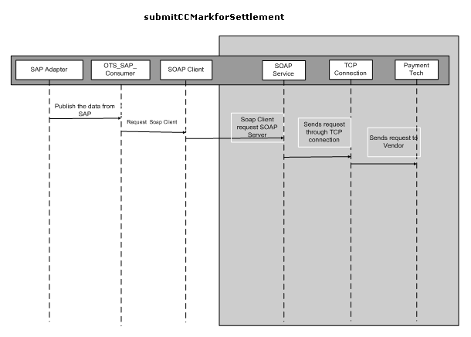

Process flow diagram:

The process steps for submitCCMarkforSettlement process are listed below.

1 | Create the EAI header for the incoming SOAP request
2 | Log the SOAP request
3 | Transform the SOAP request to Paymentech request format
4 | Send the request on the open Paymentech link
5 | If an error occurs go to step 6
6 | Call the exception handling response
7 | Map the Paymentech exception to SOAP fault
8 | Log the SOAP fault
9 | Send the SOAP fault to the client, and exit

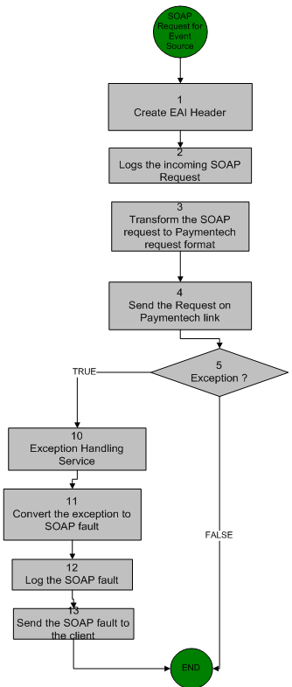

Logging and Error Handling:

All TIBCO projects log messages and errors to a central core technical services project. Every event that crosses the TIBCO boundaries is logged. Exceptions are also logged. Below is a list of exceptions that will be handled by this process

Activity | Exception Scenario | Exception Type | Comments
TCPOpen | Paymentech | System | TIBCO will try to connect for 20 times, if it still fails, a notification alert will be sent to support contact
TCPRead | Paymentech does not respond | System | TIBCO will send an error message back to SAP, informing that a timeout occurred (TIBCO will implement one retry attempt)
Mapper | Data transformation | System | There should be a proactive error acknowledge sent to the TIBCO support staff that includes some sort of descriptive text of the problem & the specific field or rule that has failed

This interface involves sensitive information like credit card numbers. The security guidelines for HMCO require that data should not be logged by TIBCO. SAP would log all the PostAuthorization requests in a secured manner. TIBCO will log process entrance, exits and exceptions as it normally does; only it will not log any data, i.e. payload will not be logged.
From a tracking perspective, the transaction ID logged in TIBCO could be used to relate to the payload in SAP.

Errors:
As per the requirements, if Paymentech does not respond in 20 seconds, TIBCO will send the request again. If still no response comes back in next 20 seconds,

TIBCO would raise a notification to the concerned support people.

eRoom Location:

https://eroom.dp.hmco.com/eRoomReq/Files/Sunrise/SunriseTechnical/0_37fbd/

FindEtailCustomer

TIBCO would wrap the SAP services for submitting a request (Customer Information) to create a Customer in SAP through a web service. The legacy System would make a HTTP request sending in the details as per SOAP specifications. The web service would extract the information and then would invoke the remote SAP function. The SAP function would do the desired processing, and would return the Customer information if it were successful or error information if it failed. This status along with the returned information will be sent by TIBCO to the SOAP client via a HTTP response.

This process contains the logic to send a request with relevant Customer information to SAP. This would require getting the information from the SOAP client, and converting this information into the required SAP format.

The total process is a synchronous job, In Synchronous call Client will send the request and waits for the response for specific period of time. If it doesn’t get the response within that time it will end the process without any knowledge of the output. On the other hand SAP could have completed the specific request and it would have sent the reply to TIBCO at a later time. This is the drawback in Synchronous calls.

Configuration Details:

SAP Adapter Configuration Details
Transport Type: JMS
Wire Format: XML
Delivery Mode: Durable
Connection Factory Type: Queue
Schema: Z_RFC_FIND_ETAIL_CUSTOMER

JMS Specifications
Transport type: JMS Queue / JMS Topic
Delivery mode: Persistent / Durable
SSL: No

Performance Indicators:

This interface should respond in 60 seconds, end to end. If no response is generated in this time frame, the interface would time out and returns a timeout error to the eCommerce/VASPA client. When a timeout error occurs, there is no guarantee about the transaction status. It may or may not be processed by SAP. The client could try re-submitting the request at some later point of time.

To prevent web services from getting repetitively timed-out, parallel async model has been put in place which generates and responds the web service call with a unique ID for retrieving the data.

Sequencing diagram:

The message flow in the following message flow diagram represents the sequence of events for processing of request coming from the legacy systems

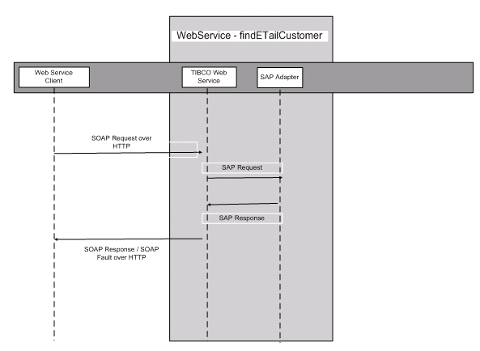

Process flow diagram:

The figure below represents the processing steps for the FindEtailCustomer service
  - SOAP Event Source – It receives the request from the web services client
  - Create the EAI header.
  - Transform the SOAP request to SAP required format
  - Perform look-up for any cross-references that may be required for the data in the incoming request
  - Invoke the SAP request reply adapter passing the request
  - If there is an exception or timeout go to next step, else go to step 11
  - Call the exception handling routine
  - Convert the exception to SOAP fault
  - Log the SOAP fault
  - Send the fault back to the web service client, and terminate
  - Convert the SAP response to SOAP response
  - Perform look-up for any cross-references that may be required for the data in the response
  - Log the SOAP response
  - Send the response back to the web service client, and terminate
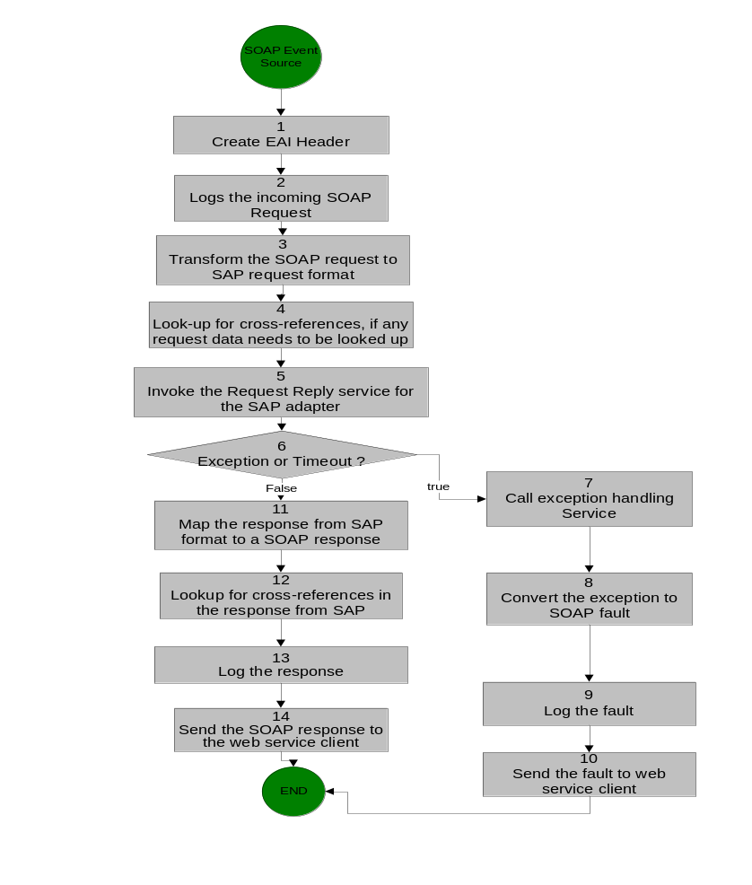

Logging and Error Handling:

All TIBCO projects log messages and errors to a central core technical services project. Every event that crosses the TIBCO boundaries is logged. Exceptions are also logged. Below is a list of exceptions that will be handled by this process.

Activity | Exception Scenario | Exception Type | Comments
Adapter | SAP Adapter down | System | SAP will send the data to TIBCO once the SAP adapter is up and running
Adapter | SAP down | System | SAP will send the data once the SAP is up and running.
Mapper | Data transformation | Business | All lexical errors will be captured via the restrictions defined in the schema. These errors will be categorized as “ERROR_CATEGORY_VALIDATION”, and the error message generated by TIBCO must be sent back to the client.
Adapter Request-Reply Service | Error  returned by the RFC | Business / System | The RFC has an export parameter “RETURN_STATUS_CODE” which would be set to a non zero value for errors. If it 1 then errorCateogry =ERROR_CATEGORY_BUSINESS and if it is 2 errorCategory= “ERROR_CATEGORY_SYSTEM”

eRoom Location:

https://eroom.dp.hmco.com/eRoom/Corporate/IntegrationSupportTeam/0_d3622

GetCustomerDetail

TIBCO would wrap the SAP services for submitting a request (Customer Information) to create a Customer in SAP through a web service. The legacy System would make a HTTP request sending in the details as per SOAP specifications. The webservice would extract the information and then would invoke the remote SAP function. The SAP function would do the desired processing, and would return the Customer information if it were successful or error information if it failed. This status along with the returned information will be sent by TIBCO to the SOAP client via a HTTP response.

This process contains the logic to send a request with relevant Customer information to SAP. This would require getting the information from the SOAP client, and converting this information into the required SAP format

Configuration Details:

SAP Adapter Configuration Details
Transport Type: JMS
Wire Format: XML
Delivery Mode: Durable
Connection Factory Type: Queue
Schema: Z_RFC_GET_CUST_DETAILS

JMS Specifications
Transport type: JMS Queue / JMS Topic
Delivery mode: Persistent / Durable
SSL: No

Performance Indicators:

This interface should respond in 60 seconds, end to end. If no response is generated in this time frame, the interface would time out and returns a timeout error to the eCommerce/VASPA client. When a timeout error occurs, there is no guarantee about the transaction status. It may or may not be processed by SAP. The client could try re-submitting the request at some later point of time.

To prevent web services from getting repetitively timed-out, parallel async model has been put in place which generates and responds the web service call with a unique ID for retrieving the data.

Sequencing diagram:

The message flow is represented in the following sequence diagram.

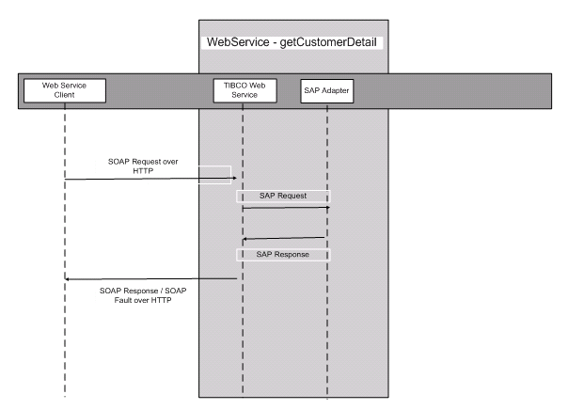

Process flow diagram:
The figure below represents the processing steps for the GetCustomerDetail service

- SOAP Event Source – It receives the request from the web services client
- Create the EAI header.
- Transform the SOAP request to SAP required format
- Perform look-up for any cross-references that may be required for the data in the incoming request
- Invoke the SAP request reply adapter passing the request
- If there is an exception or timeout go to next step, else go to step 11
- Call the exception handling routine
- Convert the exception to SOAP fault
- Log the SOAP fault
- Send the fault back to the web service client, and terminate
- Convert the SAP response to SOAP response
- Perform look-up for any cross-references that may be required for the data in the response
- Log the SOAP response
- Send the response back to the web service client, and terminate

Logging and Error Handling:

All TIBCO projects log messages and errors to a central core technical services project. Every event that crosses the TIBCO boundaries is logged. Exceptions are also logged. Below is a list of exceptions that will be handled by this process.

Activity | Exception Scenario | Exception Type | Comments
Adapter | SAP Adapter down | System | SAP will send the data to TIBCO once the SAP adapter is up and running
Adapter | SAP down | System | SAP will send the data once the SAP is up and running.
Mapper | Data transformation | Business | All lexical errors will be captured via the restrictions defined in the schema. These errors will be categorized as “ERROR_CATEGORY_VALIDATION”, and the error message generated by TIBCO must be sent back to the client.
Adapter Request-Reply Service | Error  returned by the RFC | Business / System | The RFC has an export parameter “RETURN_STATUS_CODE” which would be set to a non zero value for errors. If it 1 then errorCateogry =ERROR_CATEGORY_BUSINESS and if it is 2 errorCategory= “ERROR_CATEGORY_SYSTEM”

eRoom Location:

https://eroom.dp.hmco.com/eRoom/Corporate/IntegrationSupportTeam/0_d36ec

GetCustomerRelationships

TIBCO would wrap the SAP services for submitting a request (Customer Information) to create a Customer in SAP through a web service. The legacy System would make a HTTP request sending in the details as per SOAP specifications. The web service would extract the information and then would invoke the remote SAP function. The SAP function would do the desired processing, and would return the Customer information if it were successful or error information if it failed. This status along with the returned information will be sent by TIBCO to the SOAP client via a HTTP response.

This process contains the logic to send a request with relevant Customer information to SAP. This would require getting the information from the SOAP client, and converting this information into the required SAP format as per the mapping rules in the mapping spreadsheet.

Configuration Details:

SAP Adapter Configuration Details
Transport Type: JMS
Wire Format: XML
Delivery Mode: Durable
Connection Factory Type: Queue
Schema: Z_RFC_GET_CUST_RELATIONSHIPS

JMS Specifications

Transport type: JMS Queue / JMS Topic
Delivery mode: Persistent / Durable
SSL: No

Performance Indicators:

This interface should respond in 60 seconds, end to end. If no response is generated in this time frame, the interface would time out and returns a timeout error to the eCommerce/VASPA client. When a timeout error occurs, there is no guarantee about the transaction status. It may or may not be processed by SAP. The client could try re-submitting the request at some later point of time.

To prevent web services from getting repetitively timed-out, parallel async model has been put in place which generates and responds the web service call with a unique ID for retrieving the data.

Sequencing diagram:

The message flow in the following message flow diagram represents the sequence of events for processing of request coming from the legacy systems.

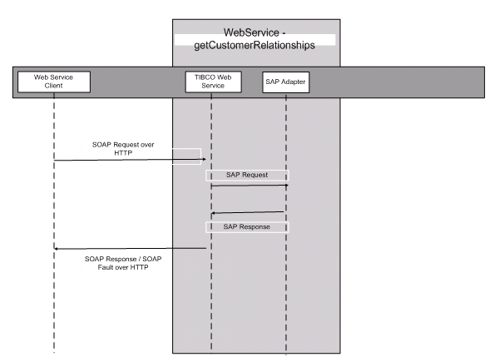

Process flow diagram:
The figure below represents the processing steps for the GetCustomerRelations service
- SOAP Event Source – It receives the request from the web services client
- Create the EAI header.
- Transform the SOAP request to SAP required format
- Perform look-up for any cross-references that may be required for the data in the incoming request
- Invoke the SAP request reply adapter passing the request
- If there is an exception or timeout go to next step, else go to step 11
- Call the exception handling routine
- Convert the exception to SOAP fault
- Log the SOAP fault
- Send the fault back to the web service client, and terminate
- Convert the SAP response to SOAP response
- Perform look-up for any cross-references that may be required for the data in the response
- Log the SOAP response
- Send the response back to the web service client, and terminate

Logging and Error Handling:

All TIBCO projects log messages and errors to a central core technical services project. Every event that crosses the TIBCO boundaries is logged. Exceptions are also logged. Below is a list of exceptions that will be handled by this process.

Activity | Exception Scenario | Exception Type | Comments
Adapter | SAP Adapter down | System | SAP will send the data to TIBCO once the SAP adapter is up and running
Adapter | SAP down | System | SAP will send the data once the SAP is up and running.
Mapper | Data transformation | Business | All lexical errors will be captured via the restrictions defined in the schema. These errors will be categorized as “ERROR_CATEGORY_VALIDATION”, and the error message generated by TIBCO must be sent back to the client.
Adapter Request-Reply Service | Error  returned by the RFC | Business / System | The RFC has an export parameter “RETURN_STATUS_CODE” which would be set to a non zero value for errors. If it 1 then errorCateogry =ERROR_CATEGORY_BUSINESS and if it is 2 errorCategory= “ERROR_CATEGORY_SYSTEM”

eRoom Location:

https://eroom.dp.hmco.com/eRoom/Corporate/IntegrationSupportTeam/0_d3bd5

GetCustomerSubstitutions
TIBCO would wrap the SAP services for submitting a request (Customer Information) to create a Customer in SAP through a web service. The legacy System would make a HTTP request sending in the details as per SOAP specifications. The web service would extract the information and then would invoke the remote SAP function. The SAP function would do the desired processing, and would return the Customer information if it were successful or error information if it failed. This status along with the returned information will be sent by TIBCO to the SOAP client via a HTTP response.

This process contains the logic to send a request with relevant Customer information to SAP. This would require getting the information from the SOAP client, and converting this information into the required SAP format as per the mapping rules in the mapping spreadsheet.

Configuration Details:

SAP Adapter Configuration Details
Transport Type: JMS
Wire Format: XML
Delivery Mode: Durable
Connection Factory Type: Queue
Schema: Z_RFC_GET_CUST_SUBSTITUTIONS

JMS Specifications
Transport type: JMS Queue / JMS Topic
Delivery mode: Persistent / Durable
SSL: No

Performance Indicators:

This interface should respond in 60 seconds, end to end. If no response is generated in this time frame, the interface would time out and returns a timeout error to the eCommerce/VASPA client. When a timeout error occurs, there is no guarantee about the transaction status. It may or may not be processed by SAP. The client could try re-submitting the request at some later point of time.

To prevent web services from getting repetitively timed-out, parallel async model has been put in place which generates and responds the web service call with a unique ID for retrieving the data.

Sequencing diagram:

The message flow in the following message flow diagram represents the sequence of events for processing of request coming from the legacy systems.

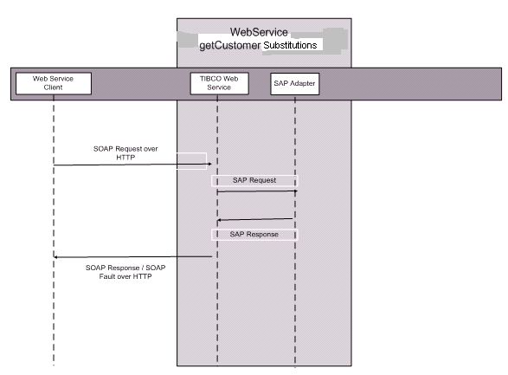

Process flow diagram:
The figure below represents the processing steps for the GetCustomerSubstitutions service
- SOAP Event Source – It receives the request from the web services client
- Create the EAI header.
- Transform the SOAP request to SAP required format
- Perform look-up for any cross-references that may be required for the data in the incoming request
- Invoke the SAP request reply adapter passing the request
- If there is an exception or timeout go to next step, else go to step 11
- Call the exception handling routine
- Convert the exception to SOAP fault
- Log the SOAP fault
- Send the fault back to the web service client, and terminate
- Convert the SAP response to SOAP response
- Perform look-up for any cross-references that may be required for the data in the response
- Log the SOAP response
- Send the response back to the web service client, and terminate

Logging and Error Handling:

All TIBCO projects log messages and errors to a central core technical services project. Every event that crosses the TIBCO boundaries is logged. Exceptions are also logged. Below is a list of exceptions that will be handled by this process.

Activity | Exception Scenario | Exception Type | Comments
Adapter | SAP Adapter down | System | SAP will send the data to TIBCO once the SAP adapter is up and running
Adapter | SAP down | System | SAP will send the data once the SAP is up and running.
Mapper | Data transformation | Business | All lexical errors will be captured via the restrictions defined in the schema. These errors will be categorized as “ERROR_CATEGORY_VALIDATION”, and the error message generated by TIBCO must be sent back to the client.
Adapter Request-Reply Service | Error  returned by the RFC | Business / System | The RFC has an export parameter “RETURN_STATUS_CODE” which would be set to a non zero value for errors. If it 1 then errorCateogry =ERROR_CATEGORY_BUSINESS and if it is 2 errorCategory= “ERROR_CATEGORY_SYSTEM”

eRoom Location:

https://eroom.dp.hmco.com/eRoom/Corporate/IntegrationSupportTeam/0_d3bd9

CreateEtailCustomer

TIBCO would wrap the SAP services for submitting a request (Customer Information) to create a Customer in SAP through a web service. The legacy System would make a HTTP request sending in the details as per SOAP specifications. The web service would extract the information and then would invoke the remote SAP function. The SAP function would do the desired processing, and would return the Customer information if it were successful or error information if it failed. This status along with the returned information will be sent by TIBCO to the SOAP client via a HTTP response.

This process contains the logic to send a request with relevant Customer information to SAP. This would require getting the information from the SOAP client, and converting this information into the required SAP format as per the mapping rules in the mapping spreadsheet.

Configuration Details:

SAP Adapter Configuration Details
Transport Type: JMS
Wire Format: XML
Delivery Mode: Durable
Connection Factory Type: Queue
Schema: Z_RFC_CREATE_ETAIL_CUSTOMER

JMS Specifications
Transport type: JMS Queue / JMS Topic
Delivery mode: Persistent / Durable
SSL: No

Performance Indicators:

This interface should respond in 60 seconds, end to end. If no response is generated in this time frame, the interface would time out and returns a timeout error to the eCommerce/VASPA client. When a timeout error occurs, there is no guarantee about the transaction status. It may or may not be processed by SAP. The client could try re-submitting the request at some later point of time.

To prevent web services from getting repetitively timed-out, parallel async model has been put in place which generates and responds the web service call with a unique ID for retrieving the data.

Sequencing diagram:

The message flow in the following message flow diagram represents the sequence of events for processing of request coming from the legacy systems.

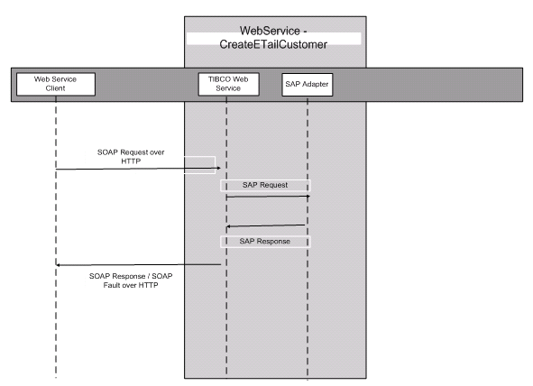

Process flow diagram:
The figure below represents the processing steps for the CreateEtailCustomer service
  - SOAP Event Source – It receives the request from the web services client
  - Create the EAI header.
  - Transform the SOAP request to SAP required format
  - Perform look-up for any cross-references that may be required for the data in the incoming request
  - Invoke the SAP request reply adapter passing the request
  - If there is an exception or timeout go to next step, else go to step 11
  - Call the exception handling routine
  - Convert the exception to SOAP fault
  - Log the SOAP fault
  - Send the fault back to the web service client, and terminate
  - Convert the SAP response to SOAP response
  - Perform look-up for any cross-references that may be required for the data in the response
  - Log the SOAP response
  - Send the response back to the web service client, and terminate

Logging and Error Handling:

All TIBCO projects log messages and errors to a central core technical services project. Every event that crosses the TIBCO boundaries is logged. Exceptions are also logged. Below is a list of exceptions that will be handled by this process.

Activity | Exception Scenario | Exception Type | Comments
Adapter | SAP Adapter down | System | SAP will send the data to TIBCO once the SAP adapter is up and running
Adapter | SAP down | System | SAP will send the data once the SAP is up and running.
Mapper | Data transformation | Business | All lexical errors will be captured via the restrictions defined in the schema. These errors will be categorized as “ERROR_CATEGORY_VALIDATION”, and the error message generated by TIBCO must be sent back to the client.
Adapter Request-Reply Service | Error  returned by the RFC | Business / System | The RFC has an export parameter “RETURN_STATUS_CODE” which would be set to a non zero value for errors. If it 1 then errorCateogry =ERROR_CATEGORY_BUSINESS and if it is 2 errorCategory= “ERROR_CATEGORY_SYSTEM”

eRoom Location:

https://eroom.dp.hmco.com/eRoom/Corporate/IntegrationSupportTeam/0_d35f8

CreateSundryCustomer
TIBCO would wrap the SAP services for submitting a request (Customer Information) to create a Customer in SAP through a web service. The legacy System would make a HTTP request sending in the details as per SOAP specifications. The web service would extract the information and then would invoke the remote SAP function. The SAP function would do the desired processing, and would return the Customer information if it were successful or error information if it failed. This status along with the returned information will be sent by TIBCO to the SOAP client via a HTTP response.

This process contains the logic to send a request with relevant Customer information to SAP. This would require getting the information from the SOAP client, and converting this information into the required SAP format as per the mapping rules in the mapping spreadsheet.

Configuration Details:

SAP Adapter Configuration Details
Transport Type: JMS
Wire Format: XML
Delivery Mode: Durable
Connection Factory Type: Queue
Schema: Z_RFC_CREATE_SUNDRY_CUSTOMER

JMS Specifications
Transport type: JMS Queue / JMS Topic
Delivery mode: Persistent / Durable
SSL: No

Performance Indicators:

This interface should respond in 60 seconds, end to end. If no response is generated in this time frame, the interface would time out and returns a timeout error to the eCommerce/VASPA client. When a timeout error occurs, there is no guarantee about the transaction status. It may or may not be processed by SAP. The client could try re-submitting the request at some later point of time.

To prevent web services from getting repetitively timed-out, parallel async model has been put in place which generates and responds the web service call with a unique ID for retrieving the data.

Sequencing diagram:

The message flow in the following message flow diagram represents the sequence of events for processing of request coming from the legacy systems.

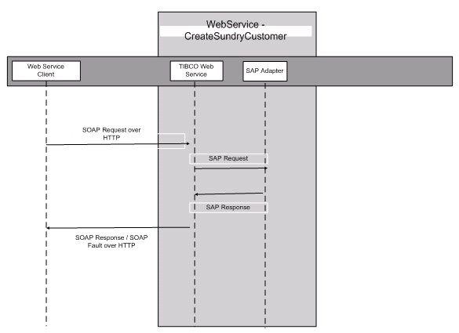

Process flow diagram:
The figure below represents the processing steps for the CreateSundryCustomer service

- SOAP Event Source – It receives the request from the web services client
- Create the EAI header.
- Transform the SOAP request to SAP required format
- Perform look-up for any cross-references that may be required for the data in the incoming request
- Invoke the SAP request reply adapter passing the request
- If there is an exception or timeout go to next step, else go to step 11
- Call the exception handling routine
- Convert the exception to SOAP fault
- Log the SOAP fault
- Send the fault back to the web service client, and terminate
- Convert the SAP response to SOAP response
- Perform look-up for any cross-references that may be required for the data in the response
- Log the SOAP response
- Send the response back to the web service client, and terminate

Logging and Error Handling:

All TIBCO projects log messages and errors to a central core technical services project. Every event that crosses the TIBCO boundaries is logged. Exceptions are also logged. Below is a list of exceptions that will be handled by this process.

Activity | Exception Scenario | Exception Type | Comments
Adapter | SAP Adapter down | System | SAP will send the data to TIBCO once the SAP adapter is up and running
Adapter | SAP down | System | SAP will send the data once the SAP is up and running.
Mapper | Data transformation | Business | All lexical errors will be captured via the restrictions defined in the schema. These errors will be categorized as “ERROR_CATEGORY_VALIDATION”, and the error message generated by TIBCO must be sent back to the client.
Adapter Request-Reply Service | Error  returned by the RFC | Business / System | The RFC has an export parameter “RETURN_STATUS_CODE” which would be set to a non zero value for errors. If it 1 then errorCateogry =ERROR_CATEGORY_BUSINESS and if it is 2 errorCategory= “ERROR_CATEGORY_SYSTEM”

eRoom Location:

https://eroom.dp.hmco.com/eRoom/Corporate/IntegrationSupportTeam/0_d361d

GetMaterialDetail

TIBCO would wrap the SAP services for submitting a request (Material ID) to get a material detail into a web service. The legacy System would make a HTTP request sending in the request as per SOAP specifications. The webservice would extract the information and then would invoke the remote SAP function. The SAP function would do the desired processing, and would return the material component information if it were successful or error information if it failed. This status along with the returned information will be sent by TIBCO to the SOAP client via a HTTP response.
The clients would send a request - ‘Material ID’, that could be either a list of valid material numbers or a list of valid ISBN numbers to TIBCO. TIBCO would require converting the request from the SOAP message, to the required SAP format as per the mapping rules in the mapping spreadsheet. On receiving the response from SAP, TIBCO would convert it back to SOAP reply or SOAP fault format, depending on whether success or exception was returned by SAP.

Configuration Details:

SAP Adapter Configuration Details
Transport Type: JMS
Wire Format: XML
Delivery Mode: Durable
Connection Factory Type: Queue
Schema: Z_RFC_GET_MATERIAL_DETAIL

JMS Specifications

Transport type: JMS Queue / JMS Topic
Delivery mode: Persistent / Durable
SSL: No

Performance Indicators:

This interface should respond in 60 seconds, end to end. If no response is generated in this time frame, the interface would time out and returns a timeout error to the eCommerce/VASPA client. When a timeout error occurs, there is no guarantee about the transaction status. It may or may not be processed by SAP. The client could try re-submitting the request at some later point of time.

To prevent web services from getting repetitively timed-out, parallel async model has been put in place which generates and responds the web service call with a unique ID for retrieving the data.

Sequencing diagram:

The message flow in the following message flow diagram represents the sequence of events for processing of request coming from the legacy systems.

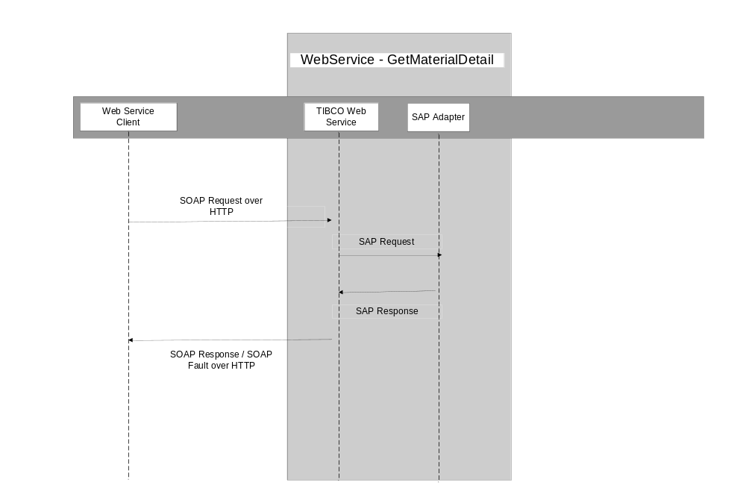

Process flow diagram:
The figure below represents the processing steps for the GetMaterialDetail service
  - SOAP Event Source – It receives the request from the web services client
  - Create the EAI header.
  - Transform the SOAP request to SAP required format
  - Perform look-up for any cross-references that may be required for the data in the incoming request
  - Invoke the SAP request reply adapter passing the request
  - If there is an exception or timeout go to next step, else go to step 11
  - Call the exception handling routine
  - Convert the exception to SOAP fault
  - Log the SOAP fault
  - Send the fault back to the web service client, and terminate
  - Convert the SAP response to SOAP response
  - Perform look-up for any cross-references that may be required for the data in the response
  - Log the SOAP response
  - Send the response back to the web service client, and terminate

Logging and Error Handling:

All TIBCO projects log messages and errors to a central core technical services project. Every event that crosses the TIBCO boundaries is logged. Exceptions are also logged. Below is a list of exceptions that will be handled by this process.

Activity | Exception Scenario | Exception Type | Comments
Adapter | SAP Adapter down | System | SAP will send the data to TIBCO once the SAP adapter is up and running
Adapter | SAP down | System | SAP will send the data once the SAP is up and running.
Mapper | Data transformation | Business | All lexical errors will be captured via the restrictions defined in the schema. These errors will be categorized as “ERROR_CATEGORY_VALIDATION”, and the error message generated by TIBCO must be sent back to the client.
Adapter Request-Reply Service | Error  returned by the RFC | Business / System | The RFC has an export parameter “RETURN_STATUS_CODE” which would be set to a non zero value for errors. If it 1 then errorCateogry =ERROR_CATEGORY_BUSINESS and if it is 2 errorCategory= “ERROR_CATEGORY_SYSTEM”. However is should be noted that for SAP returning “RETURN_STATUS_CODE” = 1, we would not be sending error, back to client. Client will see it as success. We will only create error for logging it to CTS, client does not see it as error.

eRoom Location:

https://eroom.dp.hmco.com/eRoom/Corporate/IntegrationSupportTeam/0_d32c8

GetMaterialSubstitutions

TIBCO would wrap the SAP services for submitting a request (Material ID) to get a material detail into a web service. The legacy System would make a HTTP request sending in the details as per SOAP specifications. The web service would extract the information and then would invoke the remote SAP function. The SAP function would do the desired processing, and would return the material component information if it were successful or error information if it failed. This status along with the returned information will be sent by TIBCO to the SOAP client via a HTTP response.

The clients would send a request - ‘Material ID’, that could be either a list of valid material numbers or a list of valid ISBN numbers to TIBCO. TIBCO would require converting the request from the SOAP message, to the required SAP format as per the mapping rules in the mapping spreadsheet. On receiving the response from SAP, TIBCO would convert it back to SOAP reply or SOAP fault format, depending on whether success or exception was returned by SAP.

Configuration Details:

SAP Adapter Configuration Details
Transport Type: JMS
Wire Format: XML
Delivery Mode: Durable
Connection Factory Type: Queue
Schema: 'Z_RFC_GET_MATERIAL_SUBSTITUTE'

JMS Specifications
Transport type: JMS Queue / JMS Topic
Delivery mode: Persistent / Durable
SSL: No

Performance Indicators:

This interface should respond in 60 seconds, end to end. If no response is generated in this time frame, the interface would time out and returns a timeout error to the eCommerce/VASPA client. When a timeout error occurs, there is no guarantee about the transaction status. It may or may not be processed by SAP. The client could try re-submitting the request at some later point of time.

To prevent web services from getting repetitively timed-out, parallel async model has been put in place which generates and responds the web service call with a unique ID for retrieving the data.

Sequencing diagram:

The message flow in the following message flow diagram represents the sequence of events for processing of request coming from the legacy systems.

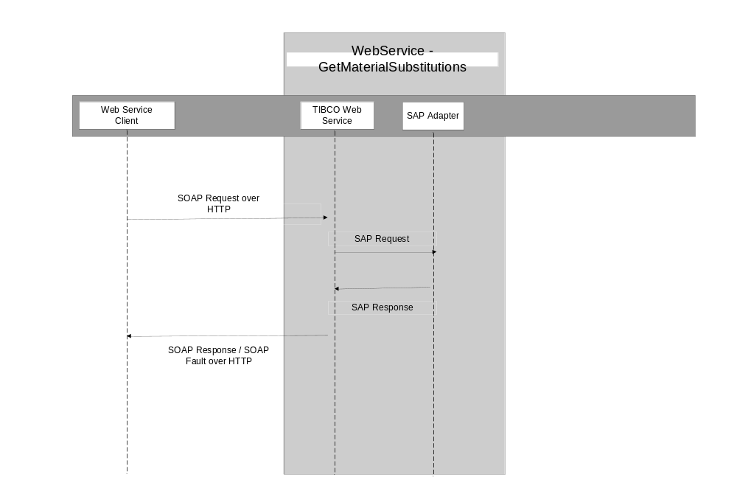

Process flow diagram:
The figure below represents the processing steps for the GetMaterialSubstitutions service
  - SOAP Event Source – It receives the request from the web services client
  - Create the EAI header.
  - Transform the SOAP request to SAP required format
  - Perform look-up for any cross-references that may be required for the data in the incoming request
  - Invoke the SAP request reply adapter passing the request
  - If there is an exception or timeout go to next step, else go to step 11
  - Call the exception handling routine
  - Convert the exception to SOAP fault
  - Log the SOAP fault
  - Send the fault back to the web service client, and terminate
  - Convert the SAP response to SOAP response
  - Perform look-up for any cross-references that may be required for the data in the response
  - Log the SOAP response
  - Send the response back to the web service client, and terminate

Logging and Error Handling:

All TIBCO projects log messages and errors to a central core technical services project. Every event that crosses the TIBCO boundaries is logged. Exceptions are also logged. Below is a list of exceptions that will be handled by this process.

Activity | Exception Scenario | Exception Type | Comments
Adapter | SAP Adapter down | System | SAP will send the data to TIBCO once the SAP adapter is up and running
Adapter | SAP down | System | SAP will send the data once the SAP is up and running.
Mapper | Data transformation | Business | All lexical errors will be captured via the restrictions defined in the schema. These errors will be categorized as “ERROR_CATEGORY_VALIDATION”, and the error message generated by TIBCO must be sent back to the client.
Adapter Request-Reply Service | Error  returned by the RFC | Business / System | The RFC has an export parameter “RETURN_STATUS_CODE” which would be set to a non zero value for errors. If it 1 then errorCateogry =ERROR_CATEGORY_BUSINESS and if it is 2 errorCategory= “ERROR_CATEGORY_SYSTEM”  However is should be noted that for SAP returning “RETURN_STATUS_CODE” = 1, we would not be sending error, back to client. Client will see it as success. We will only create error for logging it to CTS, client does not see it as error

eRoom Location:

https://eroom.dp.hmco.com/eRoom/Corporate/IntegrationSupportTeam/0_d3f45

SubmitSale

TIBCO would wrap the SAP services for creating SAP orders into a web service. The legacy System would make a HTTP request sending in the order details as per SOAP specifications. The web service would extract the information and then would invoke the remote SAP function. The SAP function would do the desired processing, and would return the order number if it were successful or error information if it failed. This status along with the returned information will be sent by TIBCO to the SOAP client via a HTTP response.

The clients would send all the order creation related details to TIBCO. TIBCO would require converting the request from the SOAP message, to the required SAP format as per the mapping rules in the mapping spreadsheet. On receiving the response from SAP, TIBCO would convert it back to SOAP reply or SOAP fault format, depending on whether success or exception was returned by SAP.
There is one more component to this interface – submitSample. These are two different web services, which interface to the same SAP remote function.

Configuration Details:

SAP Adapter Configuration Details
Transport Type: JMS
Wire Format: XML
Delivery Mode: Durable
Connection Factory Type: Queue
Schema: Z_RFC_FIND_ETAIL_CUSTOMER

JMS Specifications
Transport type: JMS Queue / JMS Topic
Delivery mode: Persistent / Durable
SSL: No

Performance Indicators:

This interface should respond in 90 seconds, end to end. If no response is generated in this time frame, the interfaces would time out and return a timeout error to the ecommerce/SFA client. When a timeout error occurs, there is no guarantee about the transaction status. It may or may not be processed by SAP. The client could try re-submitting the request at some later point of time.

To prevent web services from getting repetitively timed-out, parallel async model has been put in place which generates and responds the web service call with a unique ID for retrieving the data.

Sequencing diagram:

The message flow in the following message flow diagram represents the sequence of events for processing of request coming from the legacy systems.

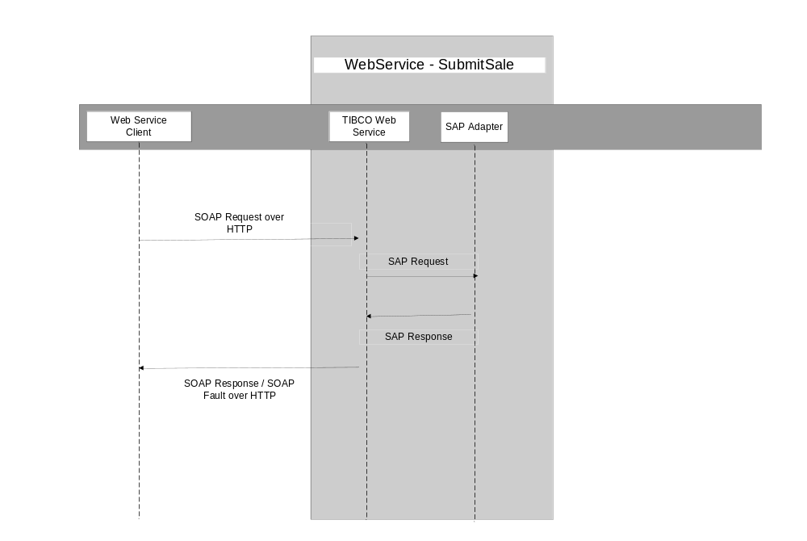

Process flow diagram:
The figure below represents the processing steps for the SubmitSale service
  - SOAP Event Source – It receives the request from the web services client
  - Create the EAI header.
  - Transform the SOAP request to SAP required format
  - Perform look-up for any cross-references that may be required for the data in the incoming request
  - Invoke the SAP request reply adapter passing the request
  - If there is an exception or timeout go to next step, else go to step 11
  - Call the exception handling routine
  - Convert the exception to SOAP fault
  - Log the SOAP fault
  - Send the fault back to the web service client, and terminate
  - Convert the SAP response to SOAP response
  - Perform look-up for any cross-references that may be required for the data in the response
  - Log the SOAP response
  - Send the response back to the web service client, and terminate

Logging and Error Handling:

All TIBCO projects log messages and errors to a central core technical services project. Every event that crosses the TIBCO boundaries is logged. Exceptions are also logged. Below is a list of exceptions that will be handled by this process.

Activity | Exception Scenario | Exception Type | Comments
Adapter | SAP Adapter down | System | SAP will send the data to TIBCO once the SAP adapter is up and running
Adapter | SAP down | System | SAP will send the data once the SAP is up and running.
Mapper | Data transformation | Business | All lexical errors will be captured via the restrictions defined in the schema. These errors will be categorized as “ERROR_CATEGORY_VALIDATION”, and the error message generated by TIBCO must be sent back to the client.

eRoom Location:

https://eroom.dp.hmco.com/eRoom/Corporate/IntegrationSupportTeam/0_d355d

SubmitSample

TIBCO would wrap the SAP services for creating SAP sample orders into a web service. The legacy System would make a HTTP request sending in the order details as per SOAP specifications. The webservice would extract the information and then would invoke the remote SAP function. The SAP function would do the desired processing, and would return the the order number if it were successful or error information if it failed. This status along with the returned information will be sent by TIBCO to the SOAP client via a HTTP response.

The clients would send all the order creation related details to TIBCO. TIBCO would require converting the request from the SOAP message, to the required SAP format as per the mapping rules in the mapping spreadsheet. On receiving the response from SAP, TIBCO would convert it back to SOAP reply or SOAP fault format, depending on whether success or exception was returned by SAP.
There is one more component to this interface – submitSale. These are two different web services, which interface to the same SAP remote function.

Configuration Details:

SAP Adapter Configuration Details
Transport Type: JMS
Wire Format: XML
Delivery Mode: Durable
Connection Factory Type: Queue
Schema: Z_VI_SL_SALES_SAMPLES_SUB

JMS Specifications
Transport type: JMS Queue / JMS Topic
Delivery mode: Persistent / Durable
SSL: No

Performance Indicators:

This interface should respond in 60 seconds, end to end. If no response is generated in this time frame, the interfaces would time out and return a timeout error to the eCommerce/VASPA client. When a timeout error occurs, there is no guarantee about the transaction status. It may or may not be processed by SAP. The client could try re-submitting the request at some later point of time.

To prevent web services from getting repetitively timed-out, parallel async model has been put in place which generates and responds the web service call with a unique ID for retrieving the data.

Sequencing diagram:

The message flow in the following message flow diagram represents the sequence of events for processing of request coming from the legacy systems.
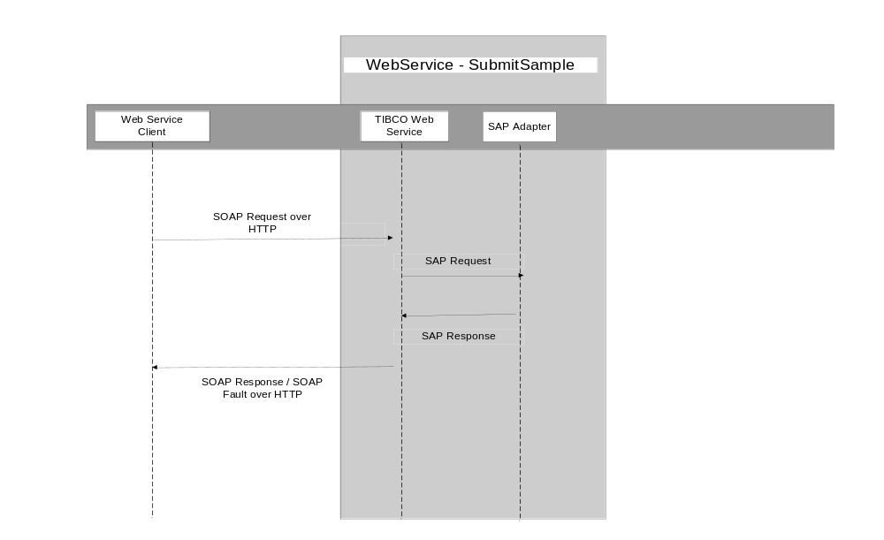

Process flow diagram:

The figure below represents the processing steps for the SubmitSample service
- SOAP Event Source – It receives the request from the web services client
- Create the EAI header.
- Transform the SOAP request to SAP required format
- Perform look-up for any cross-references that may be required for the data in the incoming request
- Invoke the SAP request reply adapter passing the request
- If there is an exception or timeout go to next step, else go to step 11
- Call the exception handling routine
- Convert the exception to SOAP fault
- Log the SOAP fault
- Send the fault back to the web service client, and terminate
- Convert the SAP response to SOAP response
- Perform look-up for any cross-references that may be required for the data in the response
- Log the SOAP response
- Send the response back to the web service client, and terminate

Logging and Error Handling:

All TIBCO projects log messages and errors to a central core technical services project. Every event that crosses the TIBCO boundaries is logged. Exceptions are also logged. Below is a list of exceptions that will be handled by this process.

Activity | Exception Scenario | Exception Type | Comments
Adapter | SAP Adapter down | System | SAP will send the data to TIBCO once the SAP adapter is up and running
Adapter | SAP down | System | SAP will send the data once the SAP is up and running.
Mapper | Data transformation | Business | All lexical errors will be captured via the restrictions defined in the schema. These errors will be categorized as “ERROR_CATEGORY_VALIDATION”, and the error message generated by TIBCO must be sent back to the client.

eRoom Location:

https://eroom.dp.hmco.com/eRoom/Corporate/IntegrationSupportTeam/0_d3560

FindTransactions

TIBCO would wrap the SAP services for submitting a request (Customer ID and limitOfResults) to get the transaction details into a web service. The legacy System would make a HTTP request sending in the request as per SOAP specifications. The webservice would extract the information and then would invoke the remote SAP function. The SAP function would do the desired processing, and would return the TransactionHistory (Transaction Detail) component information if it were successful or error information if it failed. This status along with the returned information will be sent by TIBCO to the SOAP client via a HTTP response.

The clients would send a request - ‘Customer ID and limitOfResult’s, which could be either a list of valid CustomerID to TIBCO. TIBCO would require converting the request from the SOAP message, to the required SAP format as per the mapping rules in the mapping spreadsheet. On receiving the response from SAP, TIBCO would convert it back to SOAP reply or SOAP fault format, depending on whether success or exception was returned by SAP.

Configuration Details:

SAP Adapter Configuration Details
Transport Type: JMS
Wire Format: XML
Delivery Mode: Durable
Connection Factory Type: Queue
Schema: Z_RFC_FIND_ETAIL_CUSTOMER

JMS Specifications
Transport type: JMS Queue / JMS Topic
Delivery mode: Persistent / Durable
SSL: No

Performance Indicators:

This interface should respond in 60 seconds, end to end. If no response is generated in this time frame, the interfaces would time out and return a timeout error to the eCommerce/VASPA client. When a timeout error occurs, there is no guarantee about the transaction status. It may or may not be processed by SAP. The client could try re-submitting the request at some later point of time.

To prevent web services from getting repetitively timed-out, parallel async model has been put in place which generates and responds the web service call with a unique ID for retrieving the data.

Sequencing diagram:

The message flow in the following message flow diagram represents the sequence of events for processing of request coming from the legacy systems.

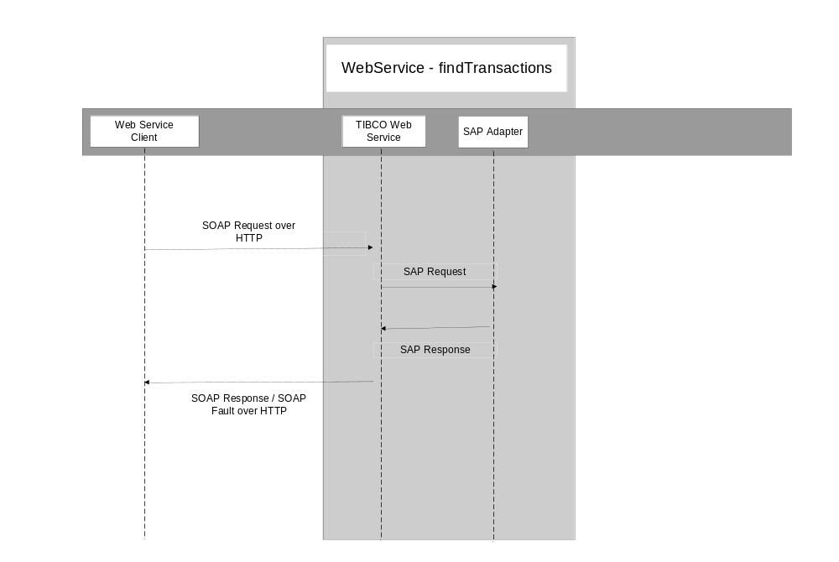

Process flow diagram:
The figure below represents the processing steps for the findTransactions service
- SOAP Event Source – It receives the request from the web services client
- Create the EAI header.
- Transform the SOAP request to SAP required format
- Perform look-up for any cross-references that may be required for the data in the incoming request
- Invoke the SAP request reply adapter passing the request
- If there is an exception or timeout go to next step, else go to step 11
- Call the exception handling routine
- Convert the exception to SOAP fault
- Log the SOAP fault
- Send the fault back to the web service client, and terminate
- Convert the SAP response to SOAP response
- Perform look-up for any cross-references that may be required for the data in the response
- Log the SOAP response
- Send the response back to the web service client, and terminate

Logging and Error Handling:

All TIBCO projects log messages and errors to a central core technical services project. Every event that crosses the TIBCO boundaries is logged. Exceptions are also logged. Below is a list of exceptions that will be handled by this process.

Activity | Exception Scenario | Exception Type | Comments
Adapter | SAP Adapter down | System | SAP will send the data to TIBCO once the SAP adapter is up and running
Adapter | SAP down | System | SAP will send the data once the SAP is up and running.
Mapper | Data transformation | Business | All lexical errors will be captured via the restrictions defined in the schema. These errors will be categorized as “ERROR_CATEGORY_VALIDATION”, and the error message generated by TIBCO must be sent back to the client.
Adapter Request-Reply Service | Error  returned by the RFC | Business / System | The RFC has an export parameter “RETURN_STATUS_CODE” which would be set to a non zero value for errors. If it 1 then errorCateogry =ERROR_CATEGORY_BUSINESS and if it is 2 errorCategory= “ERROR_CATEGORY_SYSTEM”. However is should be noted that for SAP returning “RETURN_STATUS_CODE” = 1, we would not be sending error, back to client. Client will see it as success. We will only create error for logging it to CTS, client does not see it as error.

eRoom Location:

https://eroom.dp.hmco.com/eRoom/Corporate/IntegrationSupportTeam/0_d40cb

GetInvoices

TIBCO would wrap the SAP services for submitting a request (Transaction ID) to get a Invoices details into a web service. The legacy System would make a HTTP request sending in the request as per SOAP specifications. The webservice would extract the information and then would invoke the remote SAP function. The SAP function would do the desired processing, and would return the TransactionHistory (Invoice) component information if it were successful or error information if it failed. This status along with the returned information will be sent by TIBCO to the SOAP client via a HTTP response.

The clients would send a request - ‘Transaction ID’, that could be either a list of valid Transaction numbers to TIBCO. TIBCO would require converting the request from the SOAP message, to the required SAP format as per the mapping rules in the mapping spreadsheet. On receiving the response from SAP, TIBCO would convert it back to SOAP reply or SOAP fault format, depending on whether success or exception was returned by SAP.

Configuration Details:

SAP Adapter Configuration Details
Transport Type: JMS
Wire Format: XML
Delivery Mode: Durable
Connection Factory Type: Queue
Schema: Z_RFC_GET_INVOICE

JMS Specifications
Transport type: JMS Queue / JMS Topic
Delivery mode: Persistent / Durable
SSL: No

Performance Indicators:

This interface should respond in 60 seconds, end to end. If no response is generated in this time frame, the interfaces would time out and return a timeout error to the eCommerce/VASPA client. When a timeout error occurs, there is no guarantee about the transaction status. It may or may not be processed by SAP. The client could try re-submitting the request at some later point of time.

To prevent web services from getting repetitively timed-out, parallel async model has been put in place which generates and responds the web service call with a unique ID for retrieving the data.

Sequencing diagram:

The message flow in the following message flow diagram represents the sequence of events for processing of request coming from the legacy systems.

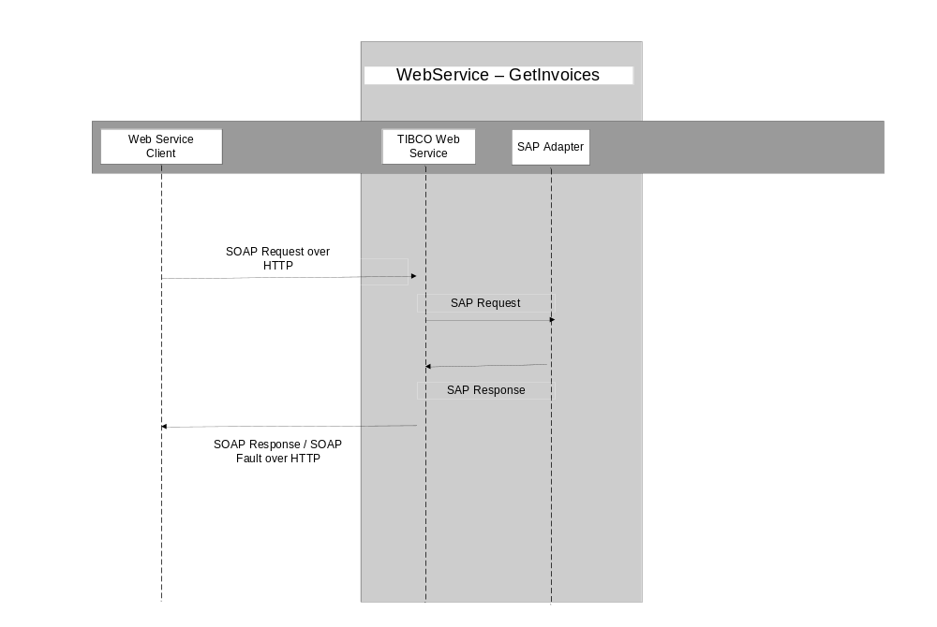

Process flow diagram:
The figure below represents the processing steps for the GetInvoices service.
- SOAP Event Source – It receives the request from the web services client
- Create the EAI header.
- Transform the SOAP request to SAP required format
- Perform look-up for any cross-references that may be required for the data in the incoming request
- Invoke the SAP request reply adapter passing the request
- If there is an exception or timeout go to next step, else go to step 11
- Call the exception handling routine
- Convert the exception to SOAP fault
- Log the SOAP fault
- Send the fault back to the web service client, and terminate
- Convert the SAP response to SOAP response
- Perform look-up for any cross-references that may be required for the data in the response
- Log the SOAP response
- Send the response back to the web service client, and terminate

Logging and Error Handling:

All TIBCO projects log messages and errors to a central core technical services project. Every event that crosses the TIBCO boundaries is logged. Exceptions are also logged. Below is a list of exceptions that will be handled by this process.

Activity | Exception Scenario | Exception Type | Comments
Adapter | SAP Adapter down | System | SAP will send the data to TIBCO once the SAP adapter is up and running
Adapter | SAP down | System | SAP will send the data once the SAP is up and running.
Mapper | Data transformation | Business | All lexical errors will be captured via the restrictions defined in the schema. These errors will be categorized as “ERROR_CATEGORY_VALIDATION”, and the error message generated by TIBCO must be sent back to the client.
Adapter Request-Reply Service | Error  returned by the RFC | Business / System | The RFC has an export parameter “RETURN_STATUS_CODE” which would be set to a non zero value for errors. If it 1 then errorCateogry =ERROR_CATEGORY_BUSINESS and if it is 2 errorCategory= “ERROR_CATEGORY_SYSTEM”. However is should be noted that for SAP returning “RETURN_STATUS_CODE” = 1, we would not be sending error, back to client. Client will see it as success. We will only create error for logging it to CTS, client does not see it as error.

eRoom Location:

https://eroom.dp.hmco.com/eRoom/Corporate/IntegrationSupportTeam/0_d36d2

GetShipments

TIBCO would wrap the SAP services for submitting a request (Transaction ID) to get a Shipments details into a web service. The legacy System would make a HTTP request sending in the request as per SOAP specifications. The web service would extract the information and then would invoke the remote SAP function. The SAP function would do the desired processing, and would return the Transaction History (Shipment) component information if it were successful or error information if it failed. This status along with the returned information will be sent by TIBCO to the SOAP client via a HTTP response.

The clients would send a request - ‘Transaction ID’, that could be either a list of valid Transaction numbers to TIBCO. TIBCO would require converting the request from the SOAP message, to the required SAP format as per the mapping rules in the mapping spreadsheet. On receiving the response from SAP, TIBCO would convert it back to SOAP reply or SOAP fault format, depending on whether success or exception was returned by SAP.

Configuration Details:

SAP Adapter Configuration Details
Transport Type: JMS
Wire Format: XML
Delivery Mode: Durable
Connection Factory Type: Queue
Schema: Z_RFC_GET_SHIPMENT

JMS Specifications
Transport type: JMS Queue / JMS Topic
Delivery mode: Persistent / Durable
SSL: No

Performance Indicators:

This interface should respond in 60 seconds, end to end. If no response is generated in this time frame, the interfaces would time out and return a timeout error to the eCommerce/VASPA client. When a timeout error occurs, there is no guarantee about the transaction status. It may or may not be processed by SAP. The client could try re-submitting the request at some later point of time.

To prevent web services from getting repetitively timed-out, parallel async model has been put in place which generates and responds the web service call with a unique ID for retrieving the data.

Sequencing diagram:

The message flow in the following message flow diagram represents the sequence of events for processing of request coming from the legacy system.

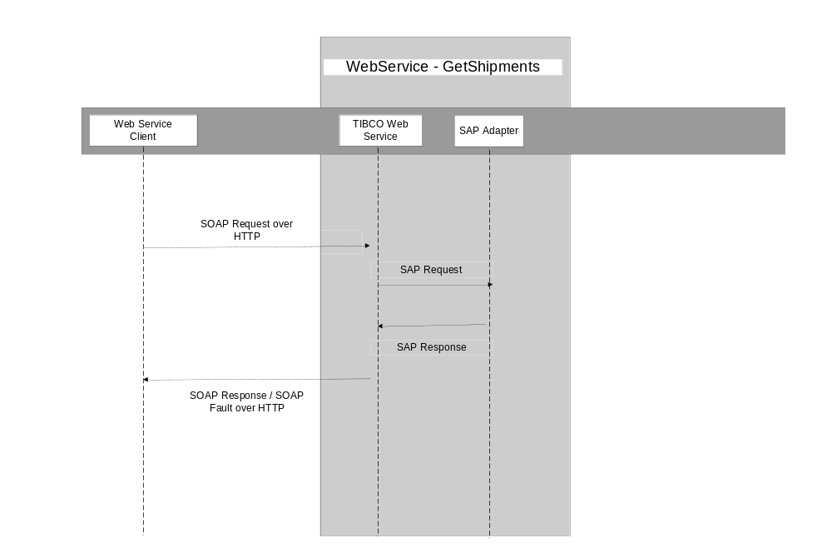

Process flow diagram:
The figure below represents the processing steps for the GetShipments service
- SOAP Event Source – It receives the request from the web services client
- Create the EAI header.
- Transform the SOAP request to SAP required format
- Perform look-up for any cross-references that may be required for the data in the incoming request
- Invoke the SAP request reply adapter passing the request
- If there is an exception or timeout go to next step, else go to step 11
- Call the exception handling routine
- Convert the exception to SOAP fault
- Log the SOAP fault
- Send the fault back to the web service client, and terminate
- Convert the SAP response to SOAP response
- Perform look-up for any cross-references that may be required for the data in the response
- Log the SOAP response
- Send the response back to the web service client, and terminate

Logging and Error Handling:

All TIBCO projects log messages and errors to a central core technical services project. Every event that crosses the TIBCO boundaries is logged. Exceptions are also logged. Below is a list of exceptions that will be handled by this process.

Activity | Exception Scenario | Exception Type | Comments
Adapter | SAP Adapter down | System | SAP will send the data to TIBCO once the SAP adapter is up and running
Adapter | SAP down | System | SAP will send the data once the SAP is up and running.
Mapper | Data transformation | Business | All lexical errors will be captured via the restrictions defined in the schema. These errors will be categorized as “ERROR_CATEGORY_VALIDATION”, and the error message generated by TIBCO must be sent back to the client.
Adapter Request-Reply Service | Error  returned by the RFC | Business / System | The RFC has an export parameter “RETURN_STATUS_CODE” which would be set to a non zero value for errors. If it 1 then errorCateogry =ERROR_CATEGORY_BUSINESS and if it is 2 errorCategory= “ERROR_CATEGORY_SYSTEM”. However is should be noted that for SAP returning “RETURN_STATUS_CODE” = 1, we would not be sending error, back to client. Client will see it as success. We will only create error for logging it to CTS, client does not see it as error.

eRoom Location:

https://eroom.dp.hmco.com/eRoom/Corporate/IntegrationSupportTeam/0_d36db

GetTransactionDetail

TIBCO would wrap the SAP services for submitting a request (Transaction ID) to get a Shipments details into a web service. The legacy System would make a HTTP request sending in the request as per SOAP specifications. The webservice would extract the information and then would invoke the remote SAP function. The SAP function would do the desired processing, and would return the TransactionHistory (Transaction Detail) component information if it were successful or error information if it failed. This status along with the returned information will be sent by TIBCO to the SOAP client via a HTTP response.

The clients would send a request - ‘Transaction ID’, that could be either a list of valid Transaction numbers to TIBCO. TIBCO would require converting the request from the SOAP message, to the required SAP format as per the mapping rules in the mapping spreadsheet. On receiving the response from SAP, TIBCO would convert it back to SOAP reply or SOAP fault format, depending on whether success or exception was returned by SAP.

Configuration Details:

SAP Adapter Configuration Details
Transport Type: JMS
Wire Format: XML
Delivery Mode: Durable
Connection Factory Type: Queue
Schema: Z_RFC_GET_TRANS_DETAIL

JMS Specifications
Transport type: JMS Queue / JMS Topic
Delivery mode: Persistent / Durable
SSL: No

Performance Indicators:

This interface should respond in 60 seconds, end to end. If no response is generated in this time frame, the interface would time out and returns a timeout error to the eCommerce/VASPA client. When a timeout error occurs, there is no guarantee about the transaction status. It may or may not be processed by SAP. The client could try re-submitting the request at some later point of time.

To prevent web services from getting repetitively timed-out, parallel async model has been put in place which generates and responds the web service call with a unique ID for retrieving the data.

Sequencing diagram:

The message flow in the following message flow diagram represents the sequence of events for processing of request coming from the legacy systems.

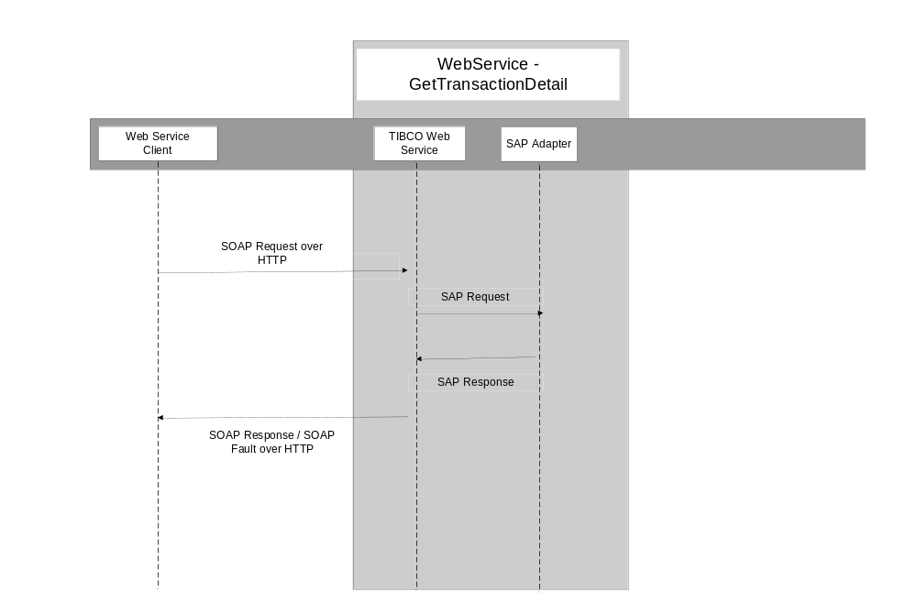

Process flow diagram:
The figure below represents the processing steps for the GetTransactionDetail service
- SOAP Event Source – It receives the request from the web services client
- Create the EAI header.
- Transform the SOAP request to SAP required format
- Perform look-up for any cross-references that may be required for the data in the incoming request
- Invoke the SAP request reply adapter passing the request
- If there is an exception or timeout go to next step, else go to step 11
- Call the exception handling routine
- Convert the exception to SOAP fault
- Log the SOAP fault
- Send the fault back to the web service client, and terminate
- Convert the SAP response to SOAP response
- Perform look-up for any cross-references that may be required for the data in the response
- Log the SOAP response
- Send the response back to the web service client, and terminate

Logging and Error Handling:

All TIBCO projects log messages and errors to a central core technical services project. Every event that crosses the TIBCO boundaries is logged. Exceptions are also logged. Below is a list of exceptions that will be handled by this process.

Activity | Exception Scenario | Exception Type | Comments
Adapter | SAP Adapter down | System | SAP will send the data to TIBCO once the SAP adapter is up and running
Adapter | SAP down | System | SAP will send the data once the SAP is up and running.
Mapper | Data transformation | Business | All lexical errors will be captured via the restrictions defined in the schema. These errors will be categorized as “ERROR_CATEGORY_VALIDATION”, and the error message generated by TIBCO must be sent back to the client.
Adapter Request-Reply Service | Error  returned by the RFC | Business / System | The RFC has an export parameter “RETURN_STATUS_CODE” which would be set to a non zero value for errors. If it 1 then errorCateogry =ERROR_CATEGORY_BUSINESS and if it is 2 errorCategory= “ERROR_CATEGORY_SYSTEM”. However is should be noted that for SAP returning “RETURN_STATUS_CODE” = 1, we would not be sending error, back to client. Client will see it as success. We will only create error for logging it to CTS, client does not see it as error.

eRoom Location:

https://eroom.dp.hmco.com/eRoom/Corporate/IntegrationSupportTeam/0_d3f3d

Change Log
Please note that this table needs to be maintained even if a Configuration Management tool is used.

Version Number | Changes made
V1.0 | Enterprise Webservices version
V1.1 | <If the change details are not explicitly documented in the table below, reference should be provided here>
V1.1 | Page no | Changed by | Effective date | Changes effected
V1.2 | <If the change details are not explicitly documented in the table below, reference should be provided here>
V1.2 | Page no | Changed by | Effective date | Changes effected

